
Proposal Cover Sheet
Term: Fall 2011
Instructor: Dr. Nora Demers

Name: Ethan Baldino

Present Year in Education (e.g., freshman, sophomore, etc.): Junior

E-mail Address: Exbaldin@Eagle.FGCU.edu

Major: Environmental Studies

Have you identified a research mentor for a senior thesis (if applicable)?
_____ Yes __X___ No.

If yes, please identify.

Name: __________________________________________

Title of Proposal:

Identifying Characteristics of Ideal Gopher Tortoise (Gopherus polyphemus) Habitat Construction for Translocated Populations

Checklist:
All required portions of the first submission are included _____ Yes _____ No

I had an external reviewer read the proposal _____ Yes _____ No

If Yes, who ________________________________________ When _______________

I authorize the use of this proposal as an example in future courses ___X__ Yes _____ No

Abstract
Gopher Tortoise populations in the state of Florida are losing more and more of their habitats to development and construction projects. My proposal hopes to eliminate this by identifying palpable translocation sites and techniques that better facilitate the needs of the tortoise. Such techniques to be experimented with include bermming construction out of different soil consistencies as well as variances in mound shapes and sizes. Once these questions are answered gopher tortoise, as well as other burrowing tortoise species will be able to be better situated to a habitat that will benefit that organism’s well being.

Key Words: Gopher tortoise, Translocation, Habitat Construction, Bermming

Table of Contents

Cover Sheet Page 1
Abstract Page 2
Table of Contents Page 3
Introduction Page 4
Research Objective Page 6
Methods Page 7
Figures Page 10
Reference List Page 11
Curriculum Vitale Page 12

Introduction
Throughout the South-Eastern United States, the burrowing Gopher Tortoise (Gopherus polyphemus) has established itself as a charismatic tenant (Baskaran et al, 2006). Within these regions the tortoise likes to inhabit “upland ecosystems characterized by sandy soils, pine forests and herbaceous understory” (Jones & Dorr, 2004). More specifically the tortoise does well in the “sandy ridges and slopes of longleaf pine clay hills” where the vegetation and the sand consistency do well to support gopher tortoise populations (Jose, Jokela & Miller, 2006).
Adequately named an ecosystem engineer, the gopher tortoise is “an organism that physically alters the abiotic environment” an invaluable service to the local fauna (Kinlaw & Grasmueck, 2011). It does this by burrowing into the soft sand and creating intricate labyrinths of tunnels that can exceed 3 meters (9.8 feet) of depth and 14.5 meters of length (48 feet) (Jose, Jokela & Miller, 2006). In one case study, more than 300 other organisms used these tunnels as a habitat in some shape or form (Kinlaw & Grasmueck, 2011). Through this commensal relationship the tortoise has been classified a keystone species, or a species “whose activities govern the well-being of many other species” (Simberloff, 1998).
Unfortunately, gopher tortoise habitats run headlong into land development projects, as more and more people move to the south (Parker, 2010). According to one observer “the single most significant loss of habitat is intensive land use, particularly housing projects, industrial centers, corporate agriculture and forestry, strip-mining and sand extraction” (Wahlquist, 2011). Because of this, the tortoise has been classified by the United States Fish and Wildlife Service as “threatened whenever found west of the Mobile and Tombigbee Rivers in Mississippi, Alabama and Louisiana”, which includes the entirety of Florida (Florida Fish and Wildlife Conservation Committee, 2007). Conservationalists and biologists have responded with a myriad of techniques to try and allay extinction fears, with relocation being the most practical option.
The concept of translocation is simple; peaceably remove a species population from an impacted area to a less impacted one. “Relocations (another term for translocation) are a commonly used, popular, and potentially powerful tool for the conservation of bio-diversity” (Fischer & Lindenmayer, 2000). However, the newly located area is not always perfect for, if it was, tortoises would already be present there. Therefore artificial habitats, specifically mounds and berms, must be created to further facilitate the new arrivals. These habitats would optimally be composed of sandy, easily dug through soil, as this is what most tortoises are familiar with (Jose, Jokela & Miller, 2006). However the experimental design of the project hopes to find different soil types and arrangements that would satiate this requirement, to further broaden the potential locations in which to place a tortoise population.
This study aspires to unearth the best possible option for creating an artificial mound. By testing various soil and sand types and consistencies and assessing which of them the tortoises are most attracted to, a new standard will be set in ensuring that relocated gopher tortoises will flourish wherever they are moved.

Research Objectives
By utilizing various berm construction techniques, such as different soil types and consistencies as well as the mound’s shape and size I hope to establish a perennial habitat construction method that best facilitates the needs of the Gopher tortoise. Another objective of the experiment is to see if common soil types found around the South Eastern U. S. could be used to the same measure as an already known successful soil type, so as to create more opportunities for habitat construction in places that might have been overlooked prior to this knowledge being unearthed, so to speak.

Methods
Study Design
I will require the necessary permits to work with a U.S. Fish and Wildlife Service classified threatened organism (Florida Fish and Wildlife Conservation Committee, 2007). I will also obtain approval from Florida Gulf Coast University’s Institutional Animal Care and Use Committee (IACUC).
Tortoise translocations ideally place the recently moved organism in a habitat that is similar to the one they were moved from (Field et al, 2007). A good location that could facilitate such a movement would be among the uplands of the northwestern panhandle of Florida (Gopher Tortoise Council, 2006). Specifically the Nokuse Plantation, a private conservation initiative, which sits on 48,000 acres of land, 27,000 of which have been set aside for gopher tortoise populations (Nokuse Plantation, 2007).
Within the region, a plot of land would be set aside and have a pen constructed for the experiment, making sure to fit the necessary spatial dimensions, twelve acres, so as to facilitate the rooming requirements of the tortoise (Jose, Jokela & Miller, 2006). Surrounding the pen will be a three-foot high heavy gauge wire chain link fence that will have another foot of fence buried underground to prevent the tortoises from burrowing under (U.S. Department of Transportation, 2003). Within the pen, two fences will run vertically across, essentially cutting the pen into thirds. These will be used to facilitate the three groups that will be used in the experiment. Pen three will then be halved horizontally, not by a physical barrier but rather by a division of the two different kinds of soil, thus splitting them into side A and B. One side will contain a sandy soil, the other a soil found in a Pine Flatwoods ecosystem (see Figure 2).
Forty-two tortoises, thirty-two adults and ten juveniles, will be selected for translocation from a recently perturbed area to the test site (Field et al, 2007). Prior to be tested, the initial weights and lengths of the tortoises will be collected. The burrows on site will also be measured by in terms height, length and depth. Each tortoise will then be screened for the various upper respiratory tract diseases (URTDs) that can proliferate among tortoise populations (Wendland et al, 2007). The subjects will then be sedated, have a tracking device attached to their carapace and put into suitable carriers for the lengthy transportation time (Field et al, 2007).
The tortoises will then be broken up into three treatment groups, with fourteen evenly distributed in each group. Group one will be dispersed into Pen one, an area covered in loose soil that has a high sand content to a depth of twelve feet. This terrain type is regularly found in an upland habitat, where gopher tortoises are usually found (Baskaran et al, 2006). This will serve as the control group. Group two will be placed into Pen two which will contain the slightly less sandy, acidic soil that is found in a Pine Flatwoods habitat, also to a depth of twelve feet. Because the Pine Flatwoods ecosystem covers 70% of Florida’s terrestrial space, it would be prudent to see if the tortoises, and their burrowing lifestyles, can function in such an easily accessible area (Jose, Jokela & Miller, 2006). The final group will be placed in Pen three, an area that would contain both kinds of soil so as to better purport the findings of the other two groups.
Data Collection
After release an observer will come to the compound once a week to check on the progress of each tortoise and its burrowing endeavors. These tortoises will be located by their tags and then undergo burrow measurements. After a six month period the weights and lengths of each tortoise will be taken and compared to the previous data taken. The burrows will also be re measured in terms of depth and length.

Data Analysis
By comparing the weights and lengths of the tortoises and the heights, lengths and depths of their burrows, an observer will be able to determine if whether or not the soil choice was logical. If a tortoise had been successful in its burrowing endeavors, than the soil choice can be seen as a possible inclusion in future translocation sites. This data can be further verified by the statistical method Analysis of Variance, ANOVA, specifically its first model, Fixed-Effects, in which multiple experiments are administered to a group to see if the response values change (Christensen, 2002).

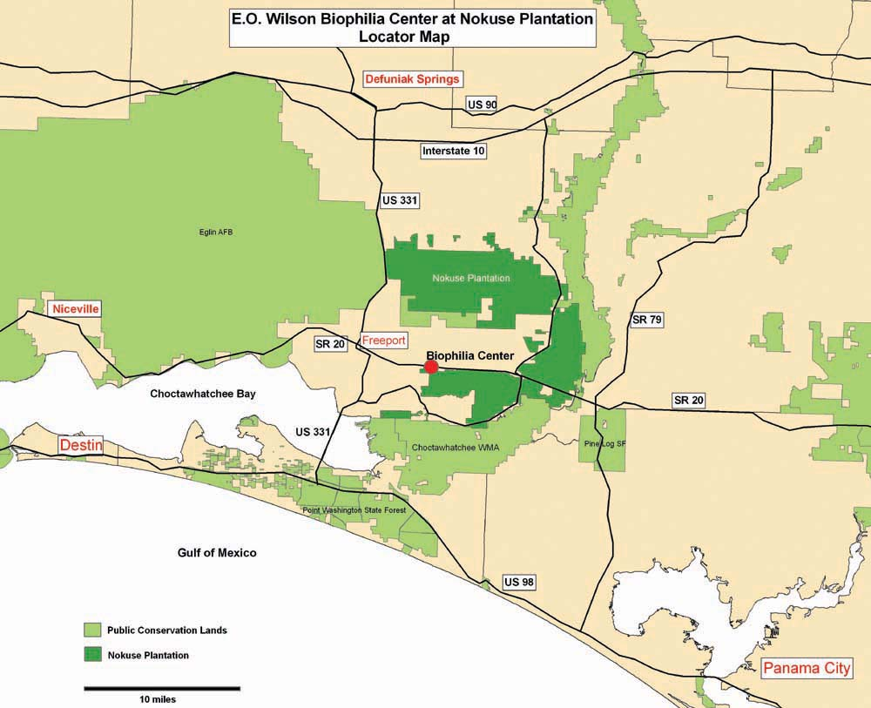
Fig 1. The designated area in which the experiment would take place.
Pen 1 | Pen 2 | A  Pen 3
Pen 1 | Pen 2 | B
Fig 2. An example of the pen to be used in the experiment.

Reference List
Baskaran, L. M., Dale, V. H., Efroymson, R. A. & Birkhead, W. (2006). Habitat Modeling with a Regional Concept: An Example Using Gopher Tortoise. American Midland Naturalist Journal. 155: 335-351.
Christensen, R. (2002). Plane Answers to Complex Questions: The Theory of Linear Models (Third Edition). New York: Springer.
Field, K. J., Tracy, C. R., Medica, P. A., Marlow, R. W., Corn, P. S. (2007, April). Return to the wild: Translocation as a tool in conservation of the Desert Tortoise (Gopherus agassizii). Biological Conservation. 136: 232-245.
Fischer, J. & Lindenmayer, D. B. (2000, July 20). An assessment of the published results of animal relocations. Biological Conservation. 96: 1-11.
Florida Fish and Wildlife Conservation Committee. (2007). Gopher Tortoise Management Plan: Gopherus polyphemus. Florida Fish and Wildlife Conservation Committee.
Gopher Tortoise Council. (2006, May). Gopher Tortoise Conservation Position Statement. Retrieved October 1, 2011 from http://www.gophertortoisecouncil.org/dox/GTC_position_stat ement_compressed.pdf
Jones, J. C. & Dorr, B. (2004). Habitat Associations of Gopher Tortoise Burrows on Industrial Timberlands. University of Nebraska-Lincoln.
Jose, S., Jokela, E. J. & Miller, D. L. (2006). The Longleaf Pine Ecosystem: Ecology, Silviculture, and Restoration. Springer Science and Business Media.
Kinlaw, A. & Grasmueck, M. (2011, July 23). Evidence for and Geomorphologic Consequences of a Reptilian Ecosystem Engineer: The Burrowing Cascade Initiated by the Gopher Tortoise. Geomorphology. 130: 1-13.
Nokuse Plantation. (2007). Welcome to the Nokuse Plantation. Retrieved October 12, 2011 from http://www.nokuse.org/index.html
Parker, L. (2010, December 24). Florida Growth Not so Slow After All. AOL News.
Simberloff, D. (1998, June 11). Flagships, umbrellas, and keystones: Is single-species management passé in the landscape era? Biological Conservation. 83: 247-257.
U.S. Department of Transportation. (2003, March 25). Fence with an Angle Protects Gopher Tortoises.
Wahlquist, G. (1991). Gopher Tortoise Conservation. Symposium on Turtles & Tortoises: Conservation & Captive Husbandry. Pages 77-79.
Wendland, L., Balbach, H., Brown, M., Berish, J. D., Littell, R. & Clark, M. (2009, January). Handbook on Gopher Tortoise (Gopherus polyphemus). Prepared for U.S. Army Corps of Engineers.

Curriculum Vitale
Ethan Baldino
14401 Lake Childs Ct, Hialeah, Fl, 33014
(786)302-2691
exbaldin@eagle.fgcu.edu
Goals
After I graduate I would like to venture out west and perhaps work for an adventuring company. After a few years of this I see myself either working for the National Park Service or returning to school and work towards becoming a high school science teacher

Education
BA: Florida Gulf Coast University, 2012, Environmental Studies
High School: Monsignor Edward Pace High School, 2009

Employment
Rhodes Law Firm, Lake Placid, Fl
Summers of 2007, 2008
Duties included: Filing, Conversing with Clients, Telephone and Computer Work, Running Errand running

Professional Societies
Florida Gulf Coast University Ultimate Frisbee Club
Member 2009-2010
Florida Gulf Coast University Rugby Football Club
Founding President 2010
Recruitment Chair 2011
Member 2010-Present
Monsignor Edward Pace High School Philosophy Club
Scribe 2008-2009

Service
Volunteer
Third Presbyterian Church, Uniontown, Pa
Summers of 2006, 2007, 2008 and 2009
Work Crew Member
Duties Included: Set Up and Breakdown of a Summer Camp’s activities, Food Preparation, Errand running, and Junior Counseling

Awards
Academic
Monsignor Edward Pace High School
Philosopher of the Year 2009
Theologian of the Year 2009
Scientific Skills
Basic Understanding of Biology, Chemistry and Environmental Biology
Laboratory Experience

Popular Press
Binninger, A. (2011, August 11). First-year Rugby Club to host September tournament. Florida Gulf Coast University: Eagle News.
Ricci, M. (2011, May 4). Newly formed rugby club aims to bring school spirit. Florida Gulf Coast University: Eagle News.

